To The Carp Gods
Is Proud to Present
Mark Gibson & Storm Free Fishery.

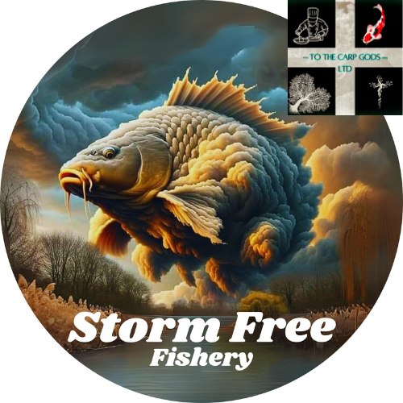

The Quiet Ripple Effect
Mark Gibson's Path to Peace at Storm Free Fishery

Table of contents
- Introduction
- The Carp Fishing Journey
- Founding Storm Free Fishery
- Mark's Philosophy
- Community and Health: Empowerment Through Cold Water Swimming
- Overcoming Challenges through Cold Water Swimming
- Storm Free Fishery Experience
- The Future Vision
- Conclusion

1.Introduction:
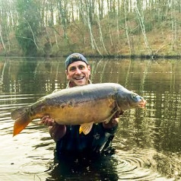
Welcome to a tranquil corner of the French countryside, where the echo of water rippling against the lake bank, whispers tales of revival and solace. This is the essence of Storm Free Fishery, a canvas painted with the deep hues of perseverance and passion by Mark Gibson, a carp angler, a chef, and a visionary with Cornish roots seeking the masterpiece within life’s complex journey.
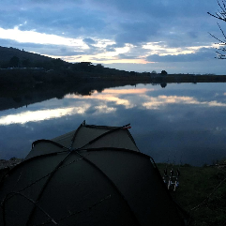
Nestled in the embracing quietude of Dompierre-les-Églises, Storm Free Fishery stands for more than a mere retreat for anglers; it symbolizes a sanctuary for all who seek refuge from life's relentless currents. It’s here that Mark's spirit and dedication intertwine with the sport of carp fishing to create an experience that transcends the act of angling to reach into the depths of personal healing and community building.
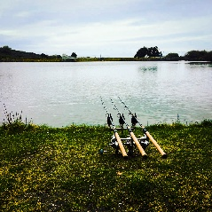
Mark views the fishery not just as a place for sport but as a living entity, where every visitor contributes to the legacy, every moment on the lake is an opportunity for inner peace, and every catch a celebration of life's victories, big and small.

The genesis of Storm Free Fishery is as layered as the history-laden waters it cradles, rooted in Mark's journey through the chiaroscuro of life's trials. His ascent from the shadowy struggles of addiction to the luminous triumph of a purpose-driven existence parallels the fish's path from the obscure lakebed to the glinting light above.

Beyond the boundaries of the fishery, Mark's passion spills into the rhythmic dedication of swimming, each stroke cutting through water and adversity alike. His Swimming Club is not just a testament to physical endurance but an emblem of the ethos that movement, growth, and wellness are intertwined threads in the fabric of life.
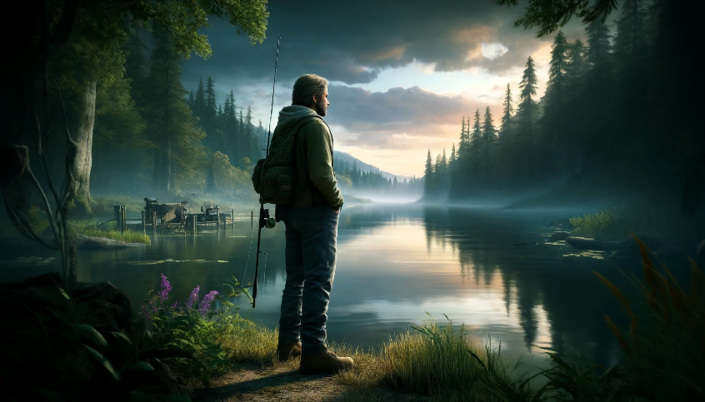
In this introductory passage, we invite you to glimpse a place where heritage is revered, the present embraced with vigour, and the future is woven with the threads of ongoing growth and learning. Storm Free Fishery is Mark Gibson's invitation to you: to engage with the legacy of carp fishing, to discover a moment of tranquillity, and perhaps, to find a reflection of yourself in the serene embrace of nature.

2. The Carp Fishing Journey:
The odyssey of Mark Gibson within the world of carp fishing is not just a pastime but a narrative that flows as deeply as the rivers of his childhood in Cornwall. It is here, against a backdrop where land meets sea and where the whispers of the Atlantic mingle with the rugged coastline, that Mark's life-long bond with carp fishing took root.
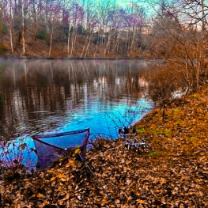
From the outset, Mark was captivated by the mystical Carp, a species storied and stealthy, drawing him into a world where patience becomes the angler’s greatest virtue and understanding the subtle language of water, his greatest skill. For Mark, carp fishing appeared as a form of solace, a conduit to a simpler existence where the weight of the world dissolved with each cast line and the steady wait for the merest tug.

In his formative years on the Cornish banks, Mark's affinity with carp fishing transcended the act of catching fish; it became an intricate dance of life itself, teaching him lessons of resilience and the art of stillness. With each dawn-lit morning and dusky evening spent by the water's edge, Mark developed a profound respect for the sport, a respect that saw the angler not as the dominator but as a humble student of nature’s profound rhythms.
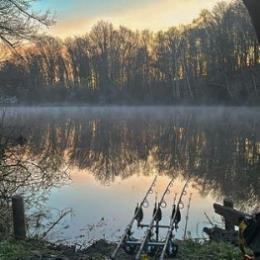
The solitude that carp fishing afforded Mark became the arena for confronting his own inner tumult. The quiet banks were witnesses to his internal battles, the struggle for self-recovery mirrored in the stillness of the lake. In the very act of waiting for the carp to rise, Mark found a metaphor for his personal journey, a testament to the power of persistence, the dignity of silence, and the promise of eventual success.

It was from this wellspring of experience that Storm Free Fishery was born, a physical and symbolic embodiment of Mark's pilgrimage through the waters of life. This fishery is not just a destination for enthusiasts; it is a shrine to the discipline and passion that carp fishing demands. It is where Mark has melded his past with his present, creating a sanctuary where each angler can partake in the same quietude that shaped his path.
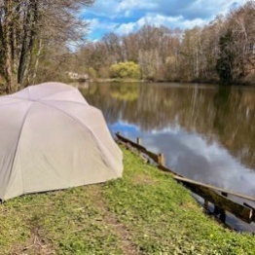
In the broader strokes of Mark Gibson's carp fishing journey, one finds not only the allure of the chase but also the wisdom that comes with it. Here, at Storm Free Fishery, the pursuit of the elusive carp becomes an allegory for life's pursuits, teaching us that the true reward often lies not in the outcome but in the patience and perseverance of the quest.

Mark has infused Storm Free Fishery with the soul of his own experiences. The waters are a living tapestry where each thread is a story, each catch a testament to the fishery’s guiding principles of respect and reflection. It is a sanctuary that beckons both the seasoned and the novice, offering not just an encounter with the majestic carp but an invitation to partake in a rite that is as ancient as the hills that cradle the waters.
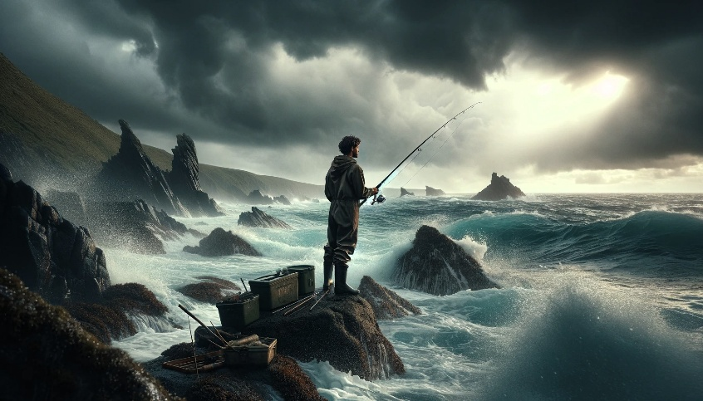
In this place, the journey of the carp is a mirror of our own, from the depths to the dappled sunlight, from obscurity to recognition. The lessons of the lake are profound: to navigate the undercurrents of existence with humility, to appreciate the silent communication of the water’s inhabitants, and to recognize in the gentle pull of the line the strength of our own resolve.

The narrative of Mark's carp fishing journey thus becomes a shared saga, a collective exploration of the parallels between man and nature, and a celebration of the bonds formed in the quiet communion with the water. At Storm Free Fishery, this journey continues, and the wisdom of the carp endures, as each visitor casts their line into both the literal and figurative waters of transformation.

3. Founding Storm Free Fishery:
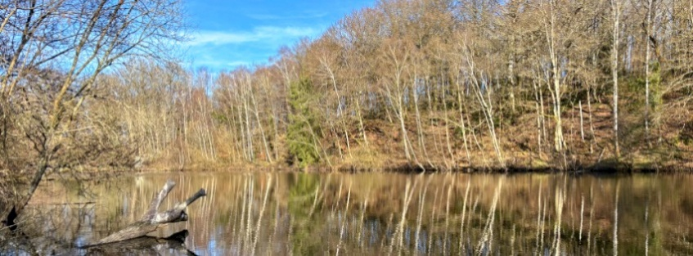
In the verdant heart of Dompierre-les-Églises, Storm Free Fishery rises as Mark Gibson's living homage to the sport of carp fishing, a sport that transcends mere recreation to embody principles of sustainability, conservation, and personal growth. It stands not only as a testament to Mark's enduring passion for angling but as a beacon of his deep-seated respect for the natural world.

The conception of Storm Free Fishery was an act of reverence, a deliberate crafting of space that serves as a natural haven for both fish and angler alike. It was here, among the quiet stretches of water and the rustling of untouched foliage, that Mark envisioned a sanctuary free from the intrusive paces of modernity, a locale where the time-honoured traditions of carp fishing could thrive unimpeded.

Nestled within this serene landscape, Mark has fostered an environment where sustainability is not an afterthought but the very pulse that gives life to the fishery. Every decision, from the nurturing of the carp stock to the preservation of the lake's biodiversity, which is informed by a commitment to environmental stewardship, a promise to future generations that the beauty and bounty of Storm Free will endure.

The founding of Storm Free Fishery also symbolises Mark’s personal narrative, one marked by resilience and rebirth. The fishery's establishment parallels his own journey from the shadowed depths of challenge to the serene surface of recovery. It is a tangible representation within his philosophy, where the dedication to the wellbeing of the natural world and the people within it takes centre stage.
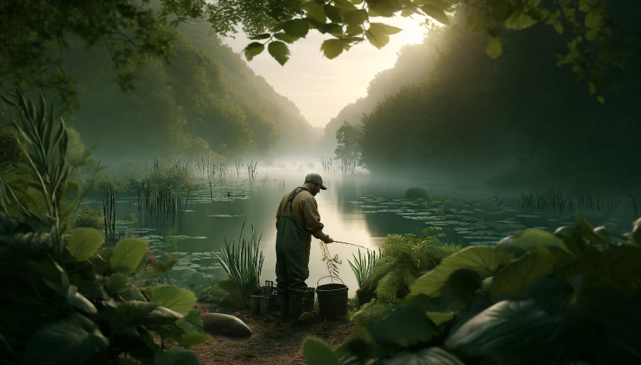Here, anglers are not mere visitors but participants in a grander story, each casting a stroke in an ongoing portrait of ecological harmony and respect. Storm Free Fishery is more than a destination; it is an experience steeped in the ethos of a man whose life reflects the very currents he fishes, a space where every individual is encouraged to engage with the environment and with themselves in a meaningful and sustaining manner.

Thus, the founding of Storm Free Fishery is not just the establishment of a new angling venue, it is the creation of a living legacy, a retreat that embodies the essence of Mark's respect for the sport, the carp, and the world that sustains them both. It is a chapter that continues to be written with each sunrise over the water of the lake, each angler's reflection on the lake’s calm surface, and every carp that graces the banks, bearing witness to the enduring vision of Mark Gibson.

4.Mark's Philosophy:
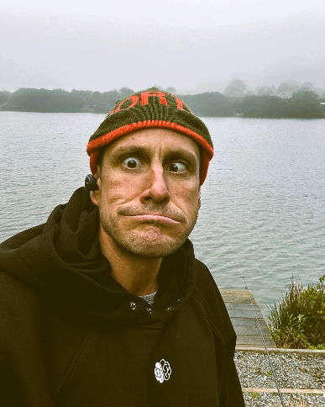
Mark Gibson’s life, like the waters he frequents, has depth, clarity, and a flow that often defies the expected course. His philosophy is born from a well of individual experiences, each layer adding richness to his approach to life, recovery, and carp fishing. In his own handwritten notes, Mark reflects on a journey that shaped his ethos, one that has carved out a sanctuary for others seeking respite and reflection at Storm Free Fishery.

Rooted deeply in the essence of Storm Free is the desire to offer a sanctuary, a place that, was much like the comforting isolation of the icy waters from his youth, provides a secure space for introspection and healing. Mark understands that everyone has their own battles, their unique adversities that can often muddy the waters of life. Storm Free Fishery stands as a clear stream in response, offering solace and peace amidst life's turbulences.
Mark's philosophy intertwines the tranquillity of nature with the tumult of human experience. He appreciates the therapeutic cadence of casting lines and waiting, knowing that the gentle pull of a rod can sometimes lead to a profound tug at the heartstrings. For Mark, fishing is more than the fish, it is about the stories of triumph and trial that every angler brings to the water's edge.
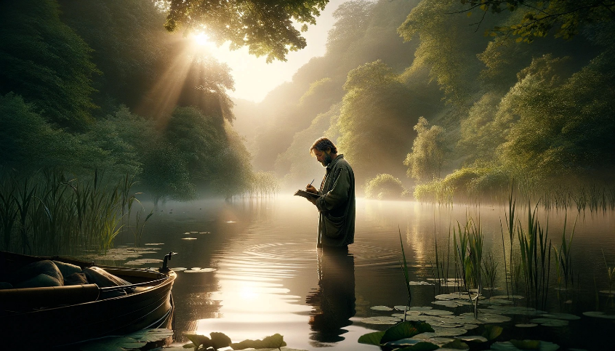
His notes allude to a spiritual solace found in nature, away from the distractions and noise of the outside world. At Storm Free, the natural world is a constant, gentle reminder of life's simple beauties, the chorus of birds at dawn, the reflective stillness of the lake, and the whispered secrets of the forest.

Yet, Mark's philosophy extends beyond environmental stewardship and into the realms of community and personal well-being. His approach is holistic, recognising the interplay between mental health and the natural environment. At Storm Free, the emphasis on sustainability includes the nurturing of human spirit and dignity. It is a place where individuals are invited to connect with nature, engage in the art of angling, and find a meditative peace that only such environments can provide.

Moreover, Mark's dedication to helping others reflects his understanding of recovery as a shared path. It is not a solitary walk but a collective journey where the strength of the community offers support and encouragement. Storm Free Fishery is, therefore, more than a mere location for fishing; it is a community hub where people can find a supportive network that empowers them to face life's challenges head-on.
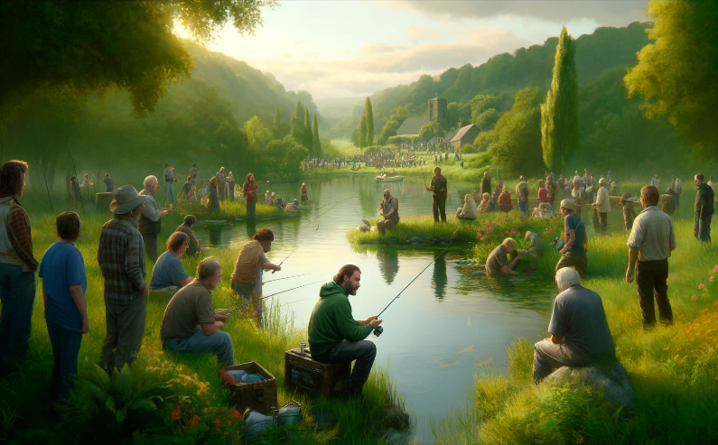
Mark's notes reiterate his belief in providing a space for people to grow, learn, and feel the raw beauty of nature, principles that have guided the foundation of Storm Free Fishery. It is a philosophy of giving back, contributing positively to the lives of others, and fostering a space where people can reconnect with the calm, therapeutic embrace of the natural world.

In summary, Mark Gibson's philosophy is a tapestry woven with threads of resilience, empathy, and profound respect for both the environment and the individuals who seek refuge in its embrace. Storm Free Fishery is the living embodiment of this philosophy, a place where the serenity of carp fishing meets the heart of human experience, offering everyone a chance to draft their own stories of peace and perseverance on the water's canvas.

5. Community and Health: Empowerment Through Cold Water Swimming
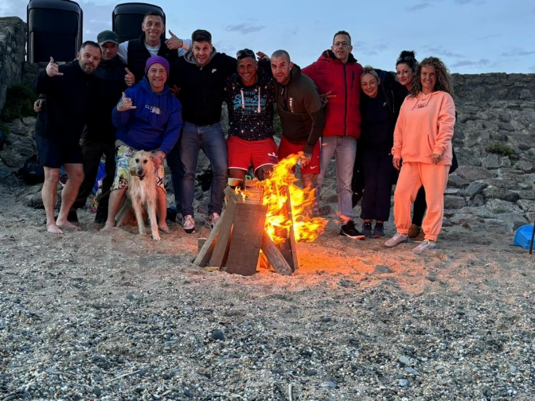
At the heart of Mark Gibson's commitment to health and community is the transformative practice of cold-water swimming, a cornerstone of his "Tidal Tonic" initiative. This program stands for more than just a gathering for swimmers; it's a testament to Mark's belief in the healing powers of nature and the strength of community support, particularly for those dealing with mental health challenges.

Mark's personal journey with cold water swimming began in the harsh yet healing waters of his youth, a practice born out of necessity to find a haven from the turbulence of his early life. As detailed in his notes, the frigid waters served as a sanctuary from the chaos of boarding school life, offering solace and a sense of security. His experiences formed a deep, enduring belief in the regenerative power of icy water, not only as a physical challenge but also as a mental release.
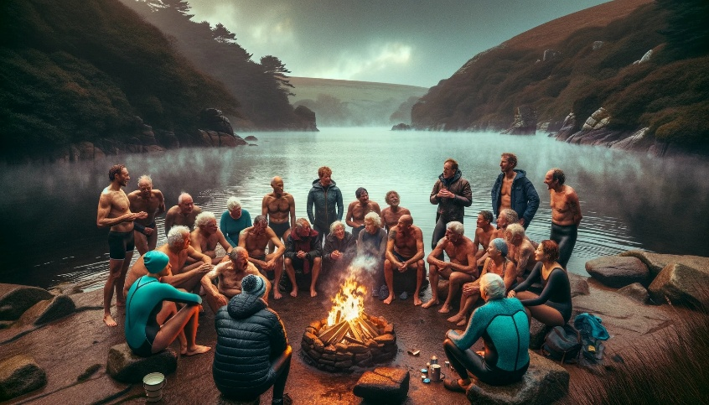
"Tidal Tonic" evolved from these foundational experiences, aimed at harnessing the therapeutic qualities of cold-water immersion to foster mental resilience and community bonding. The initiative is particularly focused on aiding individuals facing a variety of psychological stresses, including ADHD, trauma, addiction, depression, and anxiety. Through regular swims in the stunning natural beauty spots across Cornwall, "Tidal Tonic" offers participants a physical and mental rejuvenation that Mark vividly describes in his own experiences.

The program's benefits extend beyond individual health, weaving a fabric of communal support that resonates with Mark's broader philosophy. Swimming together in the cold, participants share more than just the water; they share stories, challenges, triumphs, and the communal rhythm of breathing and movement. Each session is a collective endeavour, where the freezing water acts as an equaliser, stripping away societal roles and barriers, allowing for genuine connections to be formed.
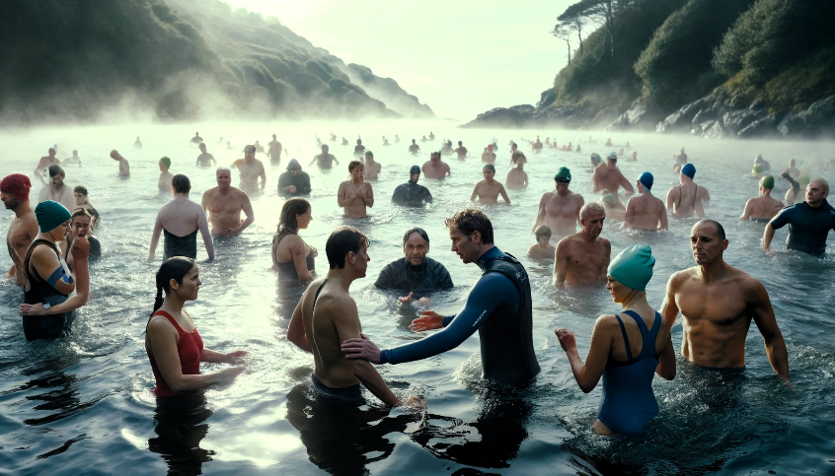
Mark's initiative also underscores the importance of accessibility and inclusivity. "Tidal Tonic" is open to all, regardless of their experience with mental health issues, reflecting his commitment to community health as a universal right. This approach is there for, enriched by the support of professionals like Melanie Philp, whose ability provides a critical backbone to the initiative, offering guidance and ensuring that those in need of more specialised support find it readily available.
In Mark's words, the act of plunging into the freezing water is akin to resetting the mind and body. The immediate shock that fades into a profound calm mirror, the journey that many undertake in their mental health battles, initial discomfort leading to long-term benefits. Participants often report feeling more alive, focused, and calm for hours, even days, after their swims, a testament to the power of Mark's water-based therapy.
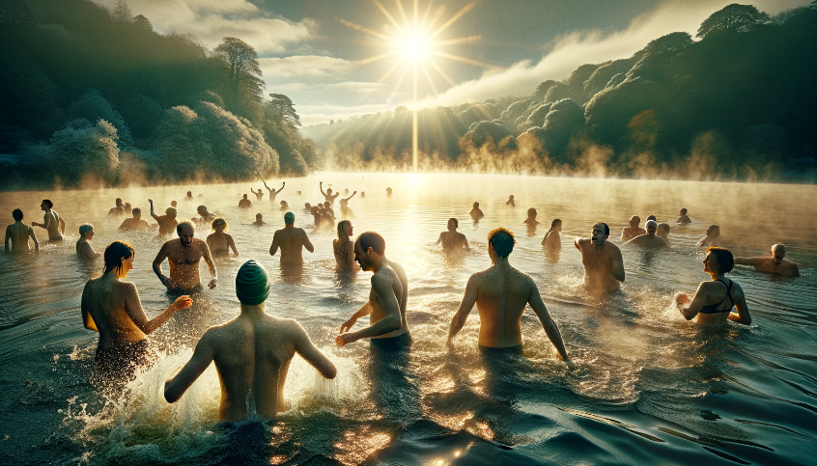
Thus, "Tidal Tonic" is not just an activity but a movement, reflecting a growing awareness of the holistic benefits of nature, exercise, and community. It is a vivid example of how Mark’s philosophy of health and connectivity is enacted, creating ripples across the community, and enriching the lives of those it touches.

Through "Tidal Tonic," Storm Free Fishery extends its reach beyond the angler community, touching the lives of those on shore, binding them in a shared journey of health, recovery, and empowerment, all under the umbrella of Mark's expansive vision for a healthier, more connected world.

6. Overcoming Challenges through Cold Water Swimming:
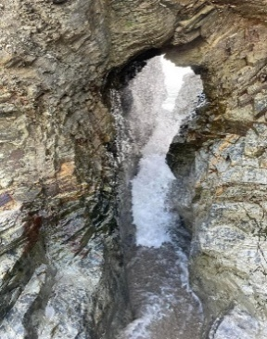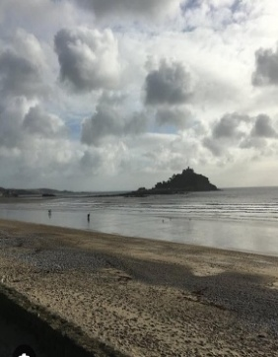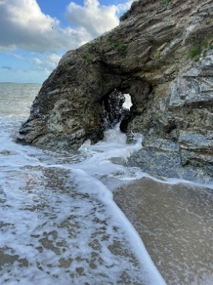
Cold water swimming has been more than a physical activity for Mark Gibson; it has been a lifeline, a method of self-preservation and healing that has threaded through his life from a turbulent youth to a reflective adulthood. This practice, deeply personal yet universally resonant, encapsulates Mark’s journey of overcoming challenges and finding resilience in the most chilling of waters.

From the cold currents of the river Tavia, near his boarding school, to the expansive waters of Cornwall, cold water swimming has provided Mark with a sanctuary away from life's troubles. His early experiences of escaping bullying by finding refuge in these frigid waters were not just acts of physical endurance but also moments of profound personal empowerment. These experiences laid the foundation for what would later evolve into a structured approach to mental and physical wellness through "Tidal Tonic."

As Mark transitioned into adulthood, the challenges changed, but the refuge offered by cold water remained constant. During his most difficult times, particularly when grappling with the shadows of addiction, the immediate and intense response of his body to cold water served as a physical and mental reset button. It was a way to momentarily silence the chaos, to wash away the burdens, and to emerge refreshed and ready to face the world anew.
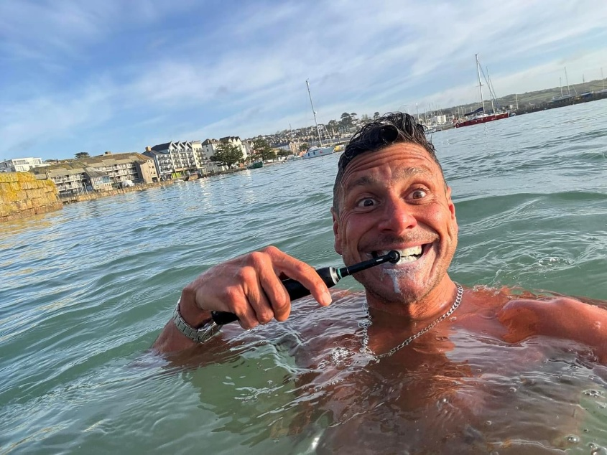
Mark's establishment of "Tidal Tonic" was a natural progression of his lifelong relationship with cold water swimming. It was a way to not only continue his own practice but also to share this powerful tool with others. By organizing community swims, he offered a pathway for individuals facing their own adversities, be it recovery from addiction, mental health struggles, or simply the everyday stressors of life.

The physiological benefits of cold-water immersion, such as improved circulation, enhanced immune response, and increased endorphin levels, are well-documented. However, for Mark and all the participants of "Tidal Tonic “cold water swimming group, these benefits extend deeper into the psychological realm. The act of entering cold water requires a moment of courage, a decision to confront discomfort head-on, which metaphorically mirrors the process of confronting personal challenges.
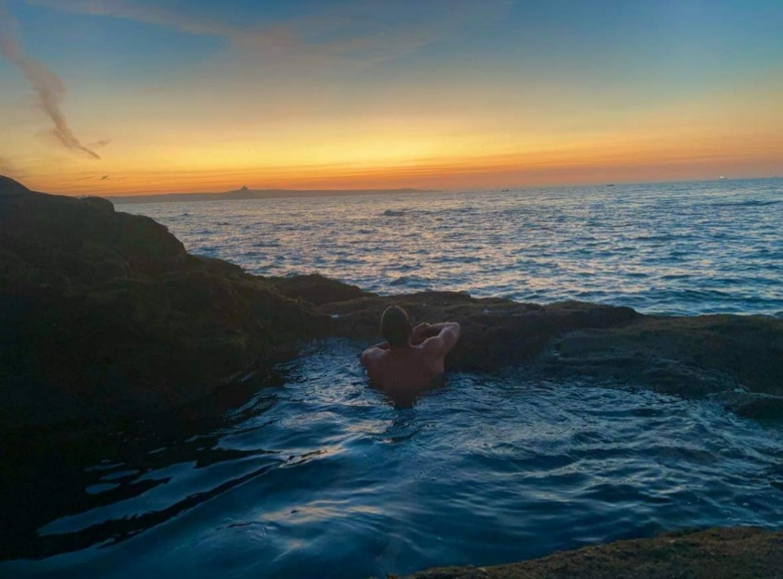
Moreover, the community aspect of "Tidal Tonic" reinforces the idea that no one needs to face their struggles alone. Each swim becomes a collective endeavour, where the support of the group enhances the individual experience. This solidarity is vital in building the confidence and motivation needed to continue the journey of recovery and personal growth.
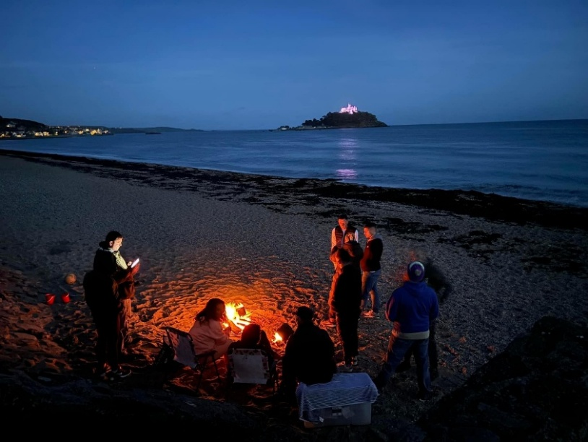
Through "Tidal Tonic," Mark has not only found a way to continue his own healing but has also created a platform for others to experience the transformative power of cold-water swimming. It is a testament to his belief that overcoming challenges often requires both a return to nature and a connection to others.
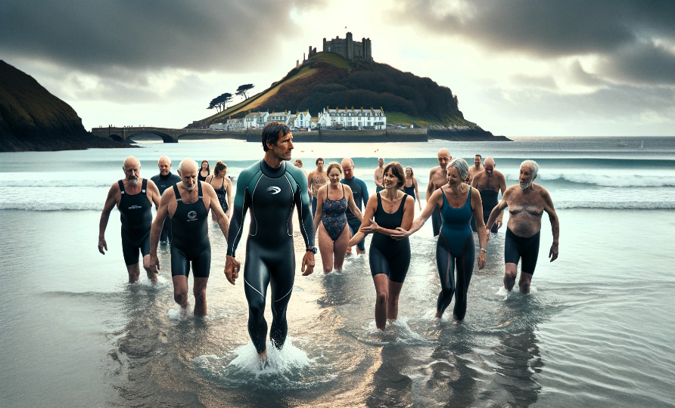
In sum, cold water swimming in Mark’s life is a vivid illustration of how a simple, natural activity can become a profound tool for overcoming life’s challenges. It underscores his commitment to health, community, and the enduring strength of the human spirit to persevere and thrive against the currents of adversity.

7. Storm Free Fishery Experience
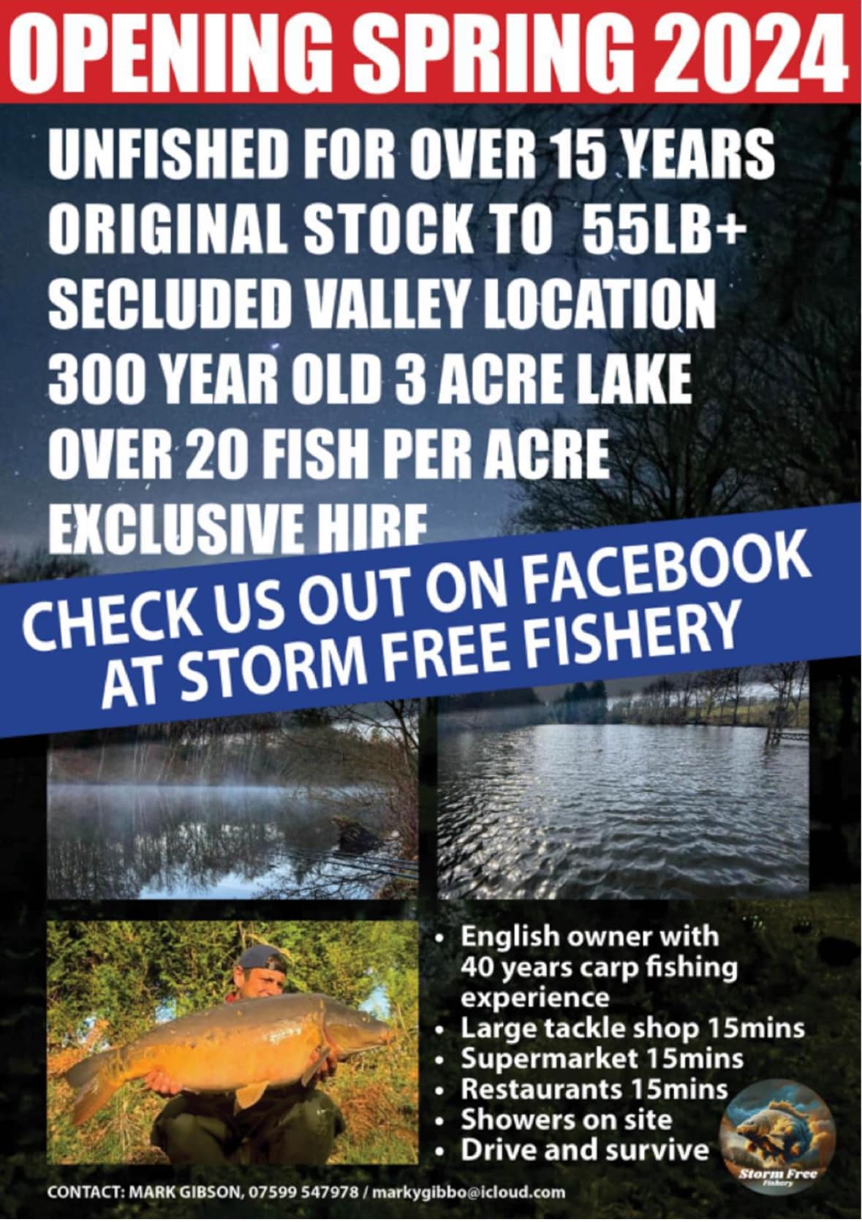
Storm Free Fishery, as envisioned and nurtured by Mark Gibson, offers a profound and holistic angling experience that transcends the mere act of fishing. It is a place where the tranquillity of nature melds seamlessly with the community spirit, creating a therapeutic sanctuary that reflects the essence of Mark’s life philosophy.

At the core of the Storm Free Fishery experience is the deep connection with nature. The fishery itself is set in a scenic locale that Mark has painstakingly preserved and enhanced, respecting the natural ecosystems while providing a haven for both wildlife and humans. This relationship with the environment is fundamental, offering visitors a chance to engage in mindful fishing, where the process is as valued as the catch to all.
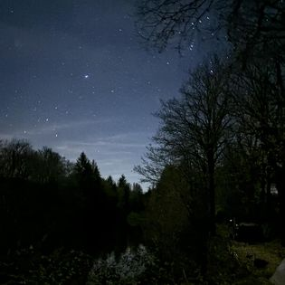
Mark's reflections on the fishery emphasise not just the serenity of the environment but also the therapeutic aspects it fosters. For many of us, the rhythmic casting of lines and the patient waiting for a bite are meditative practices that help still the mind and soothe the soul. Mark understands this intuitively, having found similar solace in his own experiences with nature and cold-water swimming.

Furthermore, the community at Storm Free Fishery reflects Mark's inclusive philosophy. It is a place where individuals from diverse backgrounds come together, drawn by their shared passion for carp fishing. However, their interaction with the fishery often leads to deeper connections, as they share stories, exchange tips, and support each other both on and off the water. This sense of belonging and mutual support is a crucial element of the fishery’s charm and appeal.
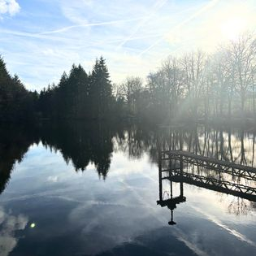
Mark also integrates educational components into the fishing experience, believing that knowledge about the sport and its environmental impact deepens the anglers' appreciation and enhances their practice. Workshops, guided sessions, and informal talks are common, fostering an atmosphere of learning and curiosity.
The Storm Free Fishery experience is also marked by its adaptability to all levels of skill and interest. Beginners find
guidance and encouragement, while seasoned anglers encounter new challenges and uncharted waters rich with elusive carp. This inclusivity ensures that everyone, regardless of their fishing prowess, feels welcomed and valued.

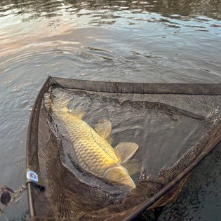
Importantly, Mark sees the fishery as a dynamic ecosystem, where the health of the water and the wellbeing of its fish are intimately connected to the health of the community that surrounds it. His efforts to maintain the purity and vitality of the lake are mirrored in Mark’s commitment to the visitors’ experience, ensuring that every aspect of Storm Free contributes to a sustainable, enriching, and enjoyable fishing adventure.
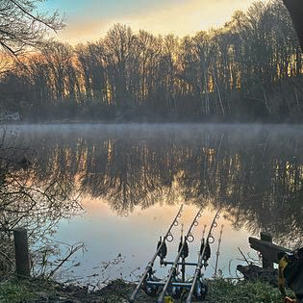
In conclusion, the Storm Free Fishery experience, as cultivated by Mark, is not merely about fishing. It is about embracing a slower pace of life, appreciating the nuances of nature, and being part of a community that values environmental stewardship and personal wellbeing. It is an invitation to step away from the rush of everyday life, to immerse oneself in a serene environment, and to join a community where each member contributes to a shared story of peace, recovery, and respectful angling.

8. The Future Vision:
Mark Gibson's vision for the future of Storm Free Fishery, to be deeply rooted in a profound commitment to education, health, sustainability, and community enrichment. With an unwavering dedication to these principles, Mark plans to expand the influence and offerings of the fishery, ensuring it remains a beacon of positive change and a model of ecological and social responsibility.

Education is a cornerstone of this future vision. Mark intends to transform Storm Free Fishery into a vibrant educational hub, where experts from various fields related to carp fishing, environmental conservation, and sustainable practices are invited to the fishery to share their Insights, knowledge, and experiences with our resident guests. The goal is to host workshops, seminars, and events that not only enrich the angling skills of participants but also deepen their understanding of ecological impacts and conservation strategies. This educational mission at the fishery through the sport of Carp angling it’s designed to foster a well-informed community of anglers who are not only adept at their sport but are also advocates for the natural world.
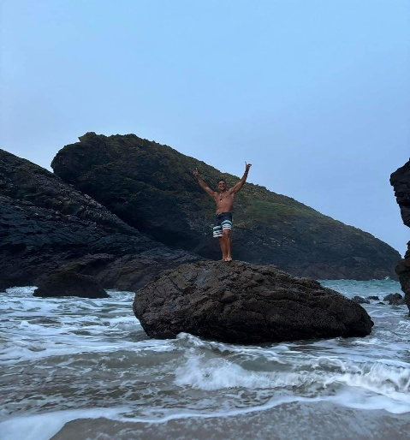
Health and wellness continue to be pivotal in Mark's plans. Drawing on his personal journey and the success of initiatives like "Tidal Tonic," Mark envisions incorporating more health-focused activities at Storm Free Fishery. This includes expanding the scope of the swimming club to offer more holistic wellness retreats, where fishing, swimming and much more, are integrated and offered to all residents at the fishery with mindfulness practices, yoga, and nature therapy Included. These retreats aim to provide a comprehensive health experience that nurtures the body, mind, and spirit, reflecting Mark's belief in the healing power of nature.
Sustainability remains at the heart of all future developments at Storm Free Fishery. Mark is committed to maintaining the ecological integrity of the fishery, ensuring that all enhancements and activities within the groups, are conducted with the utmost respect for the environment and one another. This includes continued efforts to preserve the natural habitat of the fishery, promoting catch and release practices, and using sustainable materials and methods in any physical upgrades or constructions.

Community involvement is also a key aspect of Mark's future vision. He plans to strengthen the ties between the fishery and the local community through collaborative projects, support for local environmental initiatives, and hosting family-friendly events that encourage wider community participation. Mark believes that a strong community connection not only enriches the fishery but also solidifies its role as a community asset that contributes positively to the local area.

Additionally, Mark's handwritten notes reveal plans to leverage the popularity of the fishery to support charitable causes, particularly those related to health and the environment. He aims to use events and gatherings at the fishery to raise awareness and funds for organizations like Diabetes UK, further integrating his personal passions with his professional endeavours.
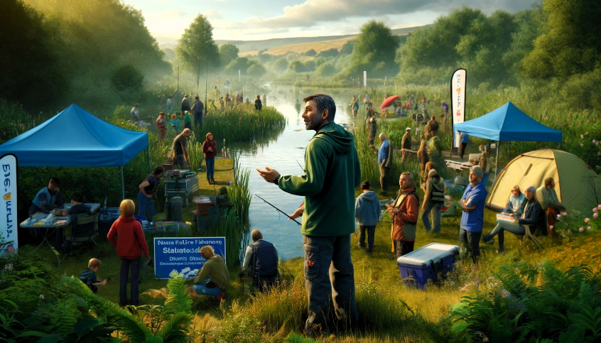
The future vision for Storm Free Fishery reflects Mark Gibson’s ongoing commitment to growth, both fishery and of the people it serves. It is about creating a legacy that transcends the sport of fishing, offering a sanctuary where education, health, sustainability, and community converge to create a truly transformative experience. As this vision unfolds, Storm Free Fishery team, residents and community are poised to not just serve as a model of responsible angling but as a living example of how passion and purpose can harmoniously align to foster a better future.

9. Conclusion
Storm Free Fishery stands as a living testament to Mark Gibson's journey, a narrative woven from the threads of personal challenge, resilience, and profound connection to the natural world. In this serene sanctuary, Mark's ethos of recovery, community, and stewardship of nature converge to create a place that transcends the typical fishing locale, embodying a deeper, more comprehensive approach to the art of angling.
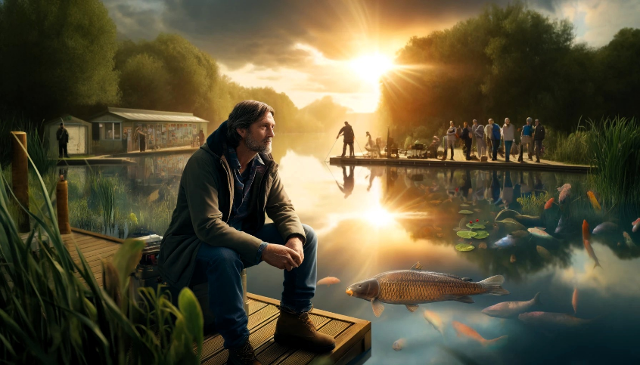
Throughout the chapters of the Storm Free story, Mark's personal evolution from a young boy finding solace in the cold waters of Cornwall to a visionary leader in the fishing community is palpable. His dedication to transforming personal adversity into a source of strength and service resonates throughout the fishery. It is a place that reflects his respect for the healing powers of nature, his commitment to sustainability, and his belief in the transformative potential of community engagement.

The ethos of Storm Free Fishery and its team our grounded in the idea that fishing is not just about catching fish but about nurturing the soul, respecting the environment, and forging bonds that strengthen individual and community resilience. Here, the legacy of traditional carp fishing is cherished by all Carp anglers alike and passed on, not just through techniques and tales but through shared experiences that highlight the sport’s capacity to teach patience, persistence, and respect for the rhythms of nature.
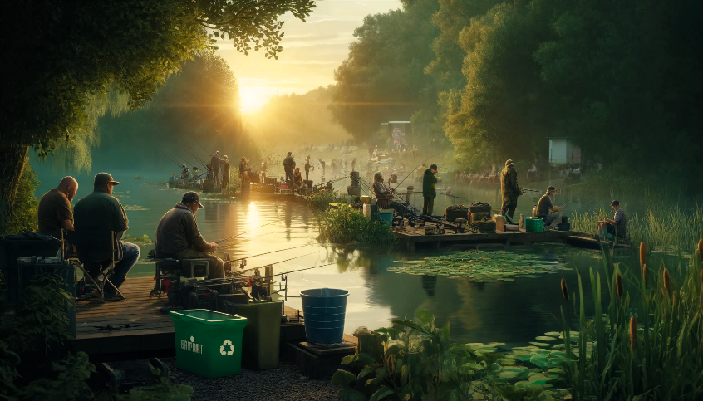
As Mark looks to the future, his vision extends beyond maintaining the pristine condition of the fishery or expanding its facilities. He envisions Storm Free as a beacon of education, a haven of wellness, and a community pillar that upholds the values of environmental conservation and social responsibility. Each planned workshop, each community event, and each swim in the cold, rejuvenating waters is a step towards realizing this comprehensive vision.

In conclusion, Storm Free Fishery is more than a destination; it is a journey. It is a place where anglers can find not only the thrill of the catch but also the peace of mind that comes with being part of a caring, mindful community. It is a place where each visit leaves an imprint on the soul and where the legacy of Mark Gibson’s life’s work continues to inspire and empower.
We invite you to visit Storm Free Fishery, to cast your line into its storied waters, and to experience for yourself the tranquillity, the challenge, and the community that make this place utterly unique. Here, you will find more than fish; you will discover a story of resilience, a refuge for recovery, and a community that welcomes all who share a love for the great outdoors and the art of fishing. Join us, and become a part of this ongoing, beautiful story.

